

**DEPARTMENT OF COMPUTER SCIENCE & SERVICES**

CENTRE FOR DIPLOMA STUDIES, SPACE

**DSPD 1703**

WEB PROGRAMMING

**PROJECT REPORT**

**LECTURER NAME**

**SECTION 44**

**STUDENT NAME & MATRIC ID**

LEE XUAN HUI

A24DW0423

**WEBSITE:**

https://wp-assignment-leexuanhui.w3spaces.com

**Table of Contents**

1.0 Main menu 2

1.1 PersonalInformation.html 5

1.2 CV.html 7

1.3 Subtopic (use heading 2) 7

1.3.1 Sub-subtopic (use heading 3) 7

1.3.2 Sub-subtopic (use heading 3) 7

1.3.3 Sub-subtopic (use heading 3) 7

2.0 Topic (use heading 1) 8

2.1 Subtopic (use heading 2) 8

2.2 Subtopic (use heading 2) 8

2.3 Subtopic (use heading 2) 8

2.3.1 Sub-subtopic (use heading 3) 8

2.3.2 Sub-subtopic (use heading 3) 8

2.3.3 Sub-subtopic (use heading 3) 8

3.0 Topic (use heading 1) 8

3.1 Subtopic (use heading 2) 8

# Main menu

Coding:

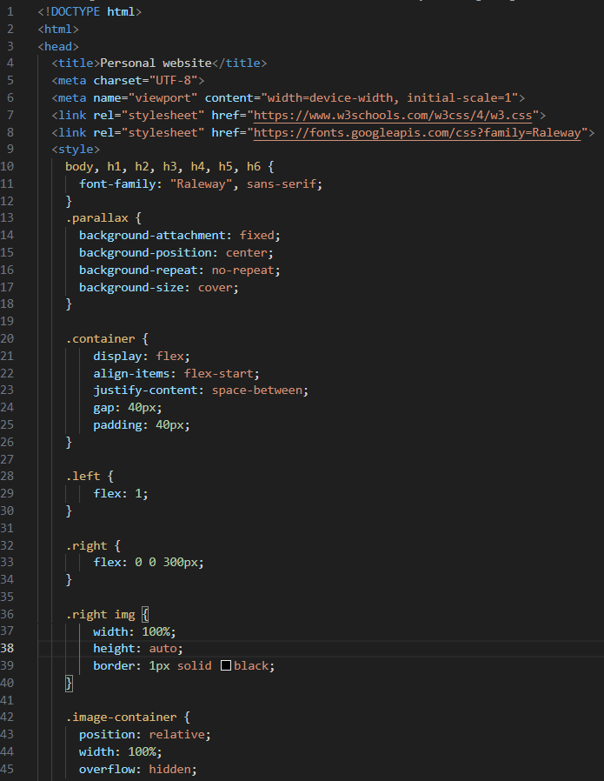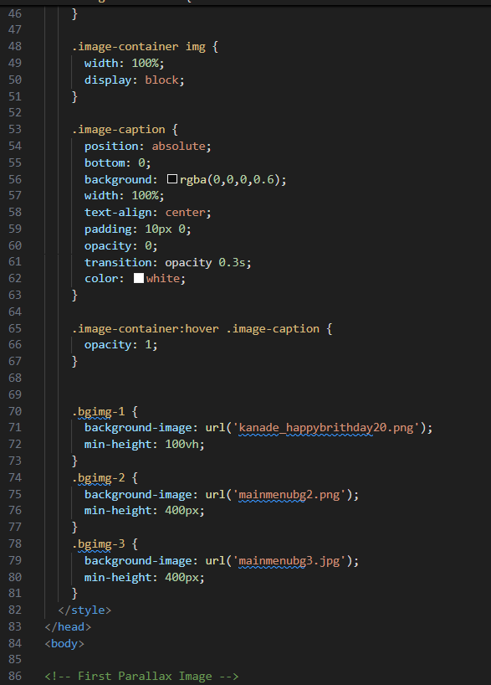

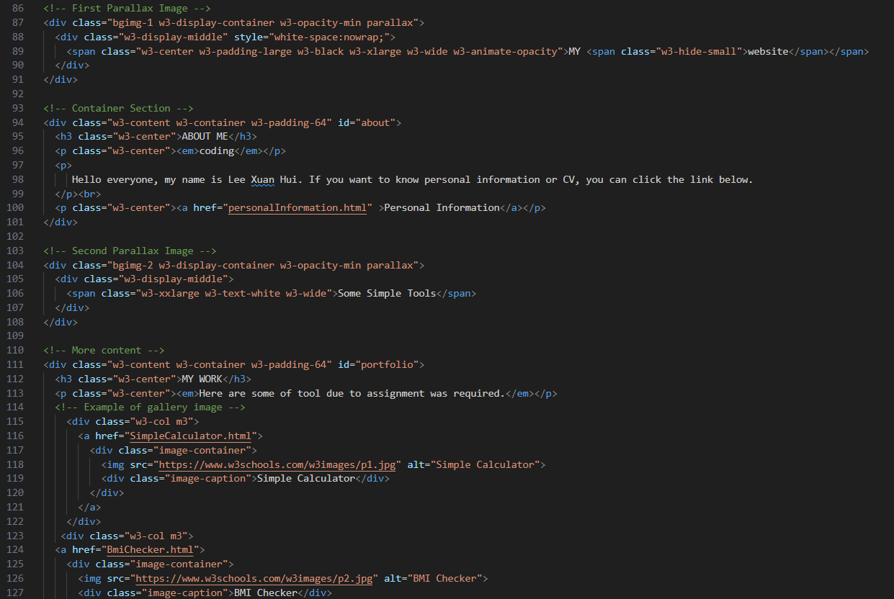

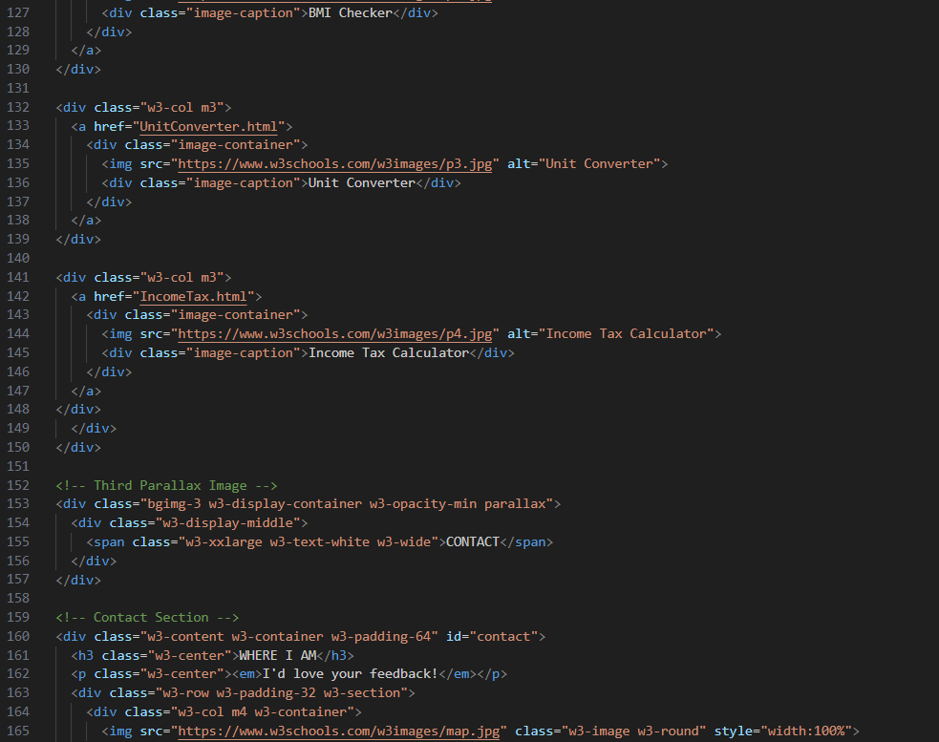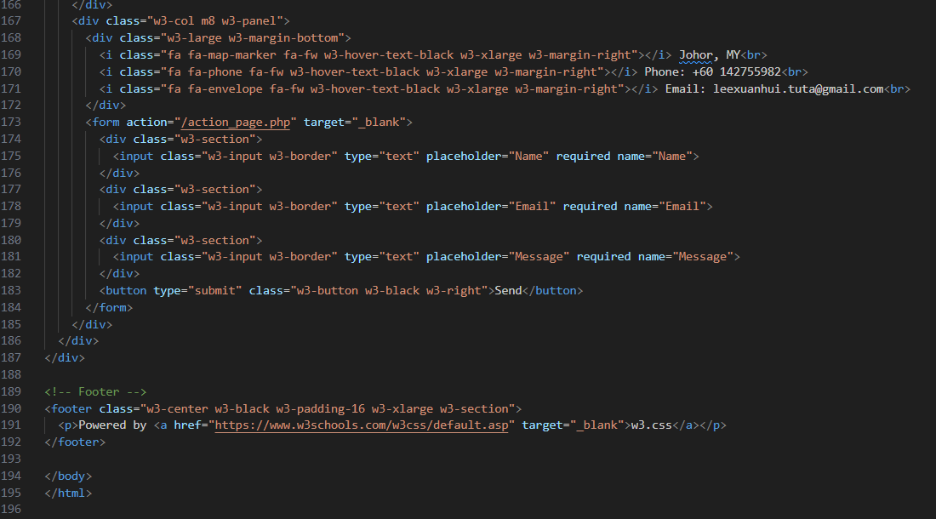

Output:



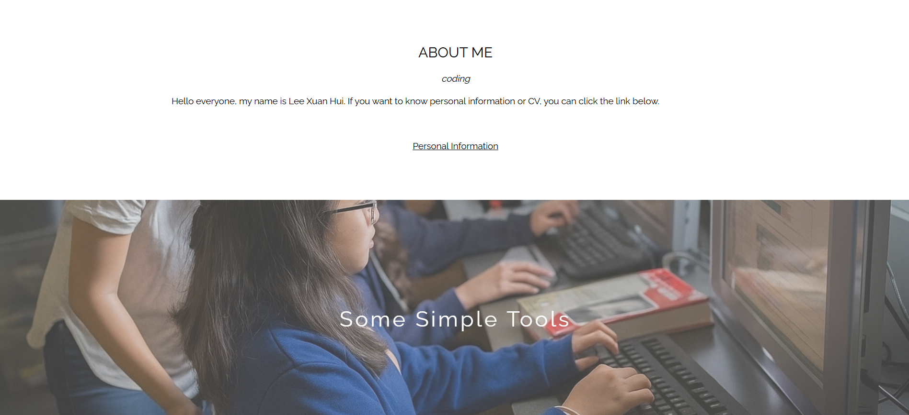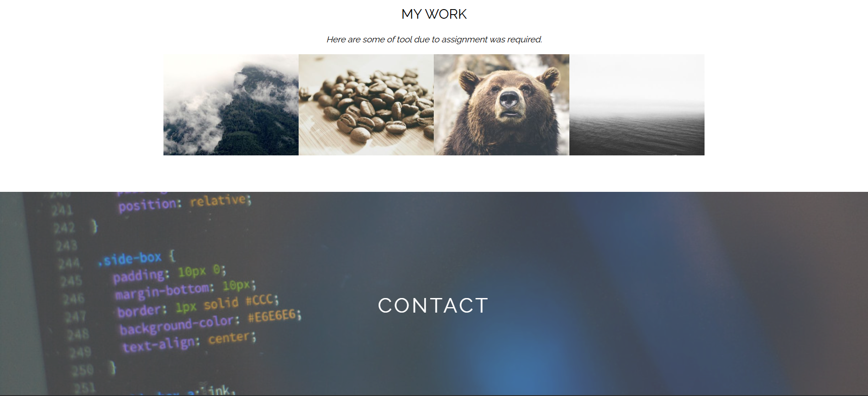

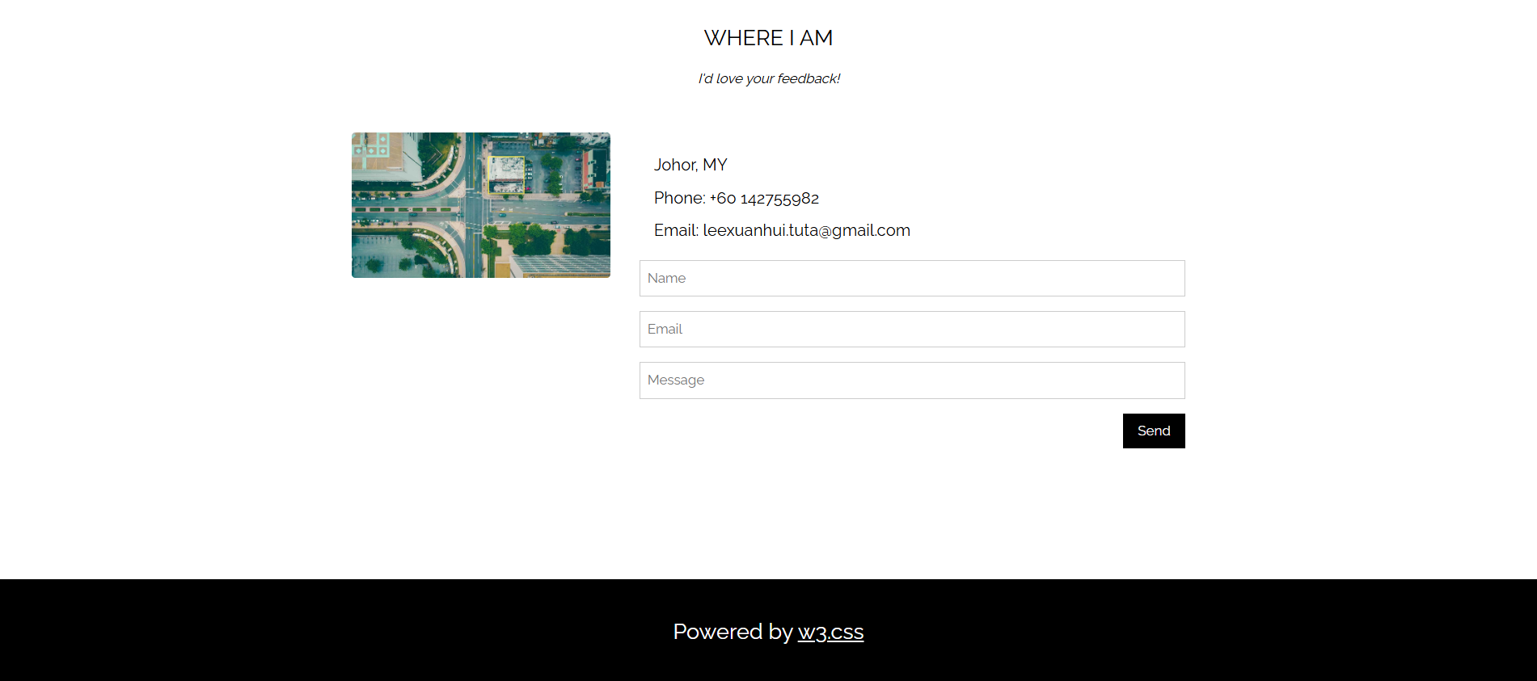

## 1.1 PersonalInformation.html

Coding:

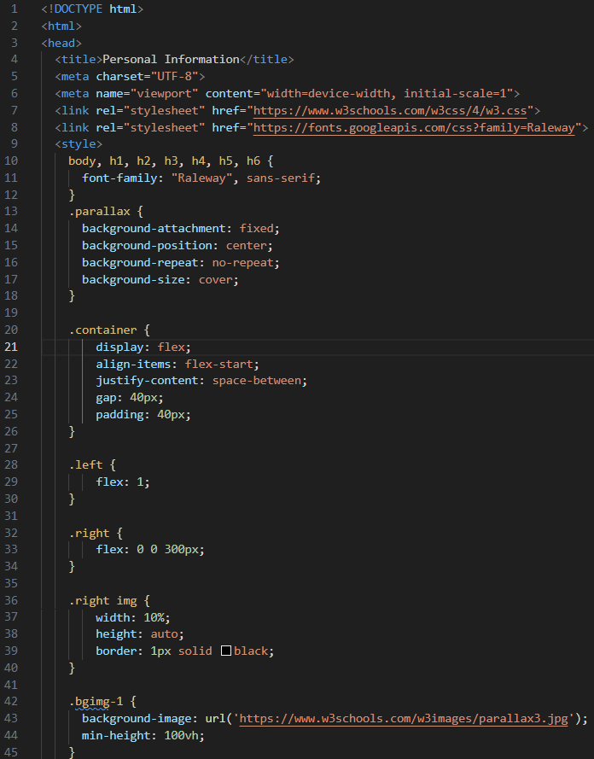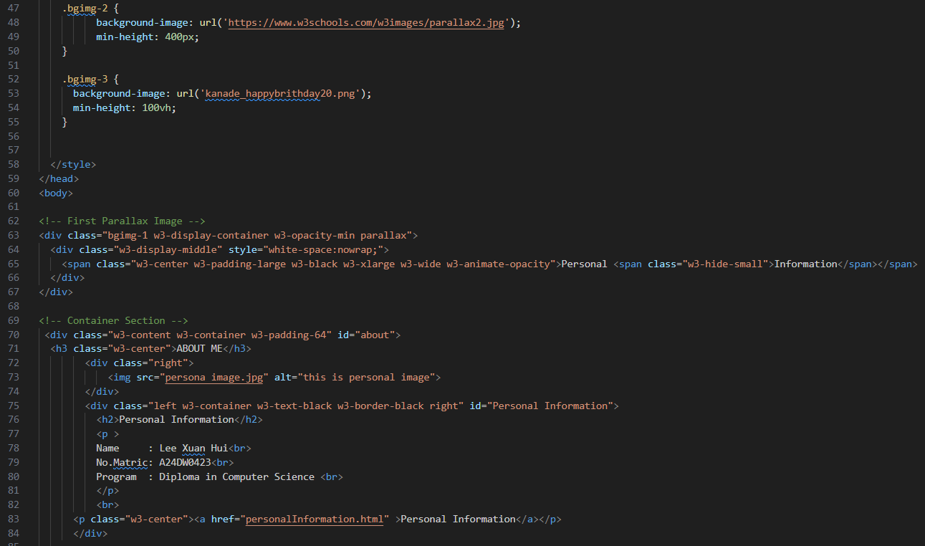

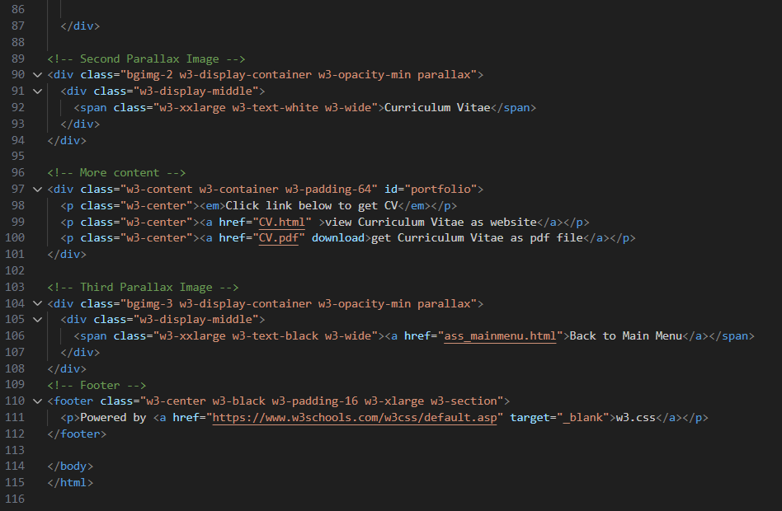

Output:







## 1.2 CV.html

Coding:

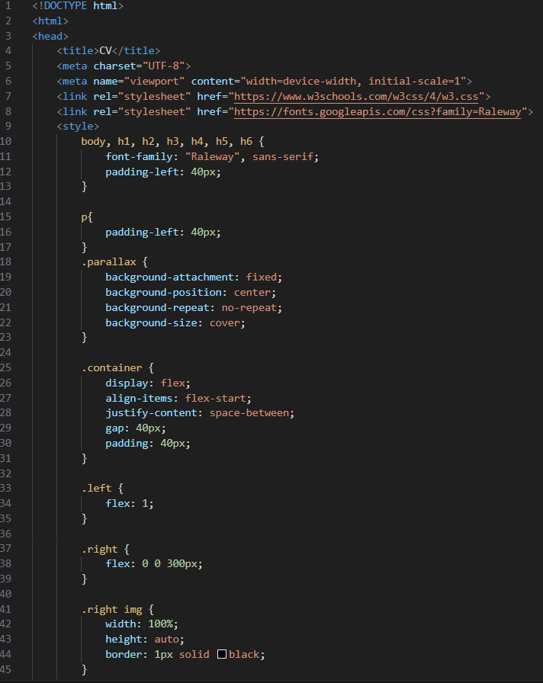

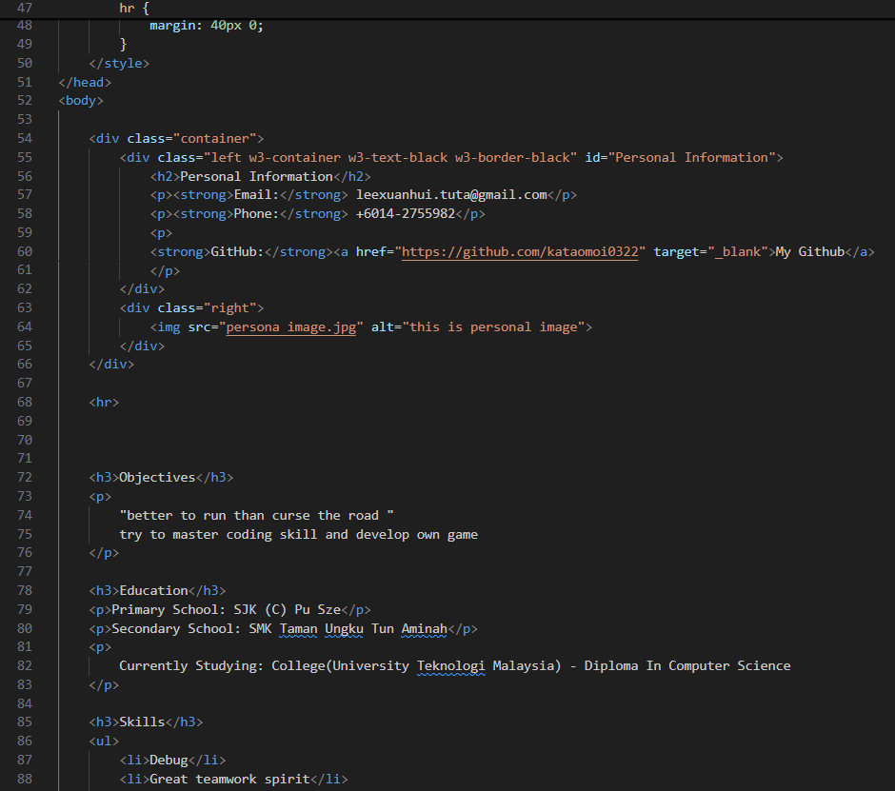

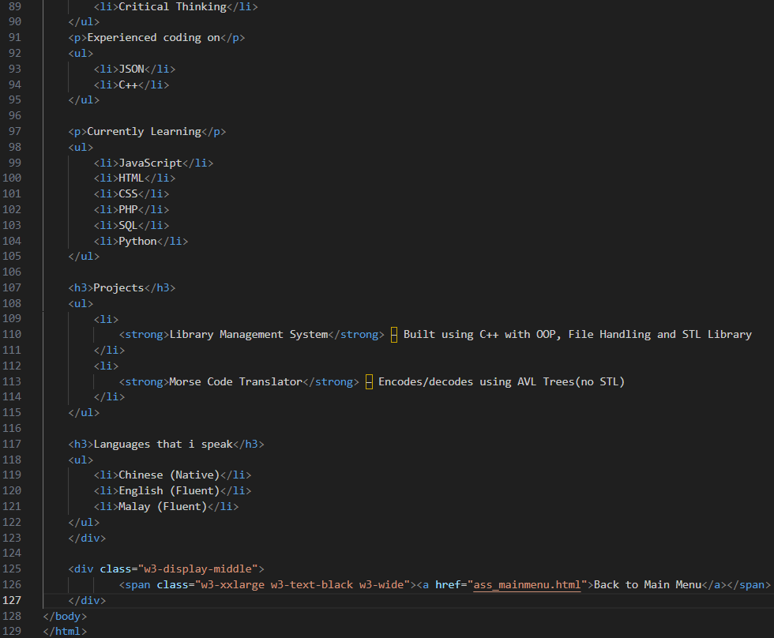

Output:

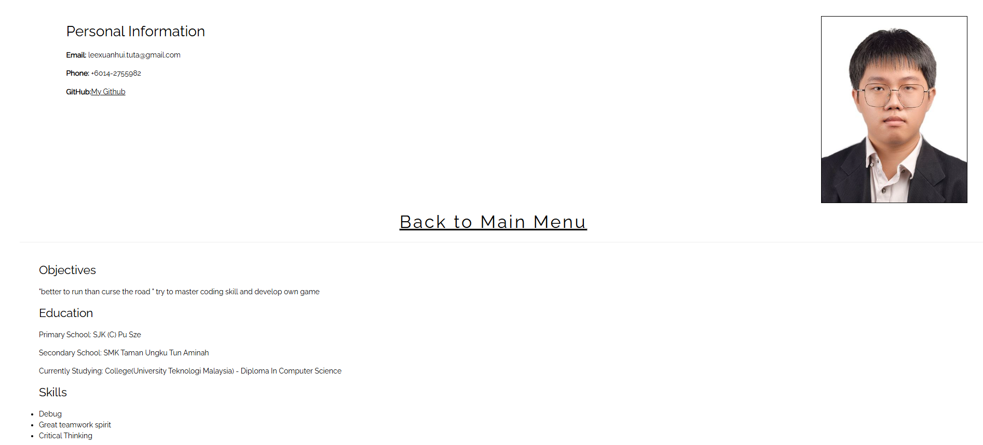

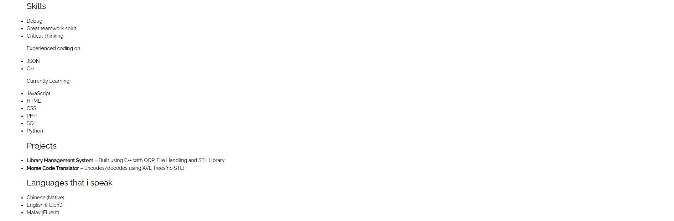

## 1.3 IncomeTax.html

Coding:

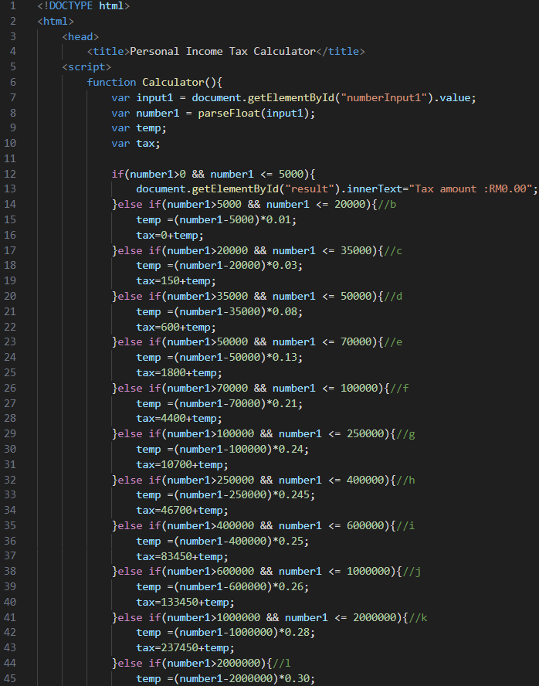

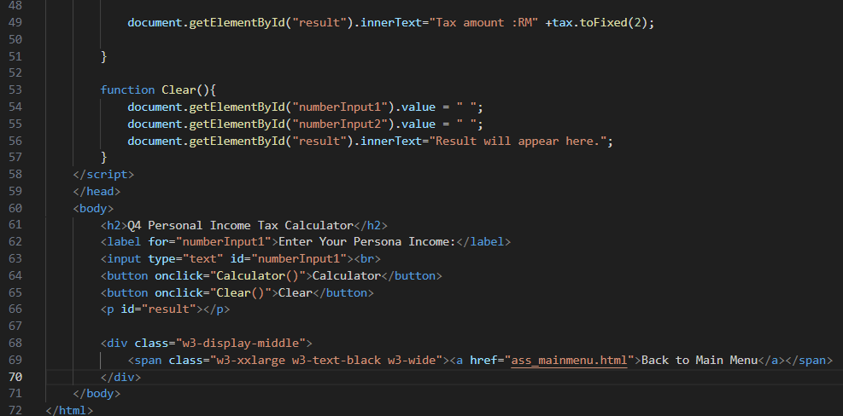

Output:

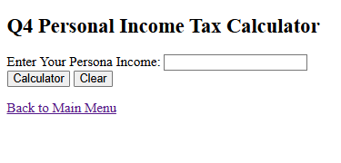

### 1.3.1 BMIChecker.html

Coding:

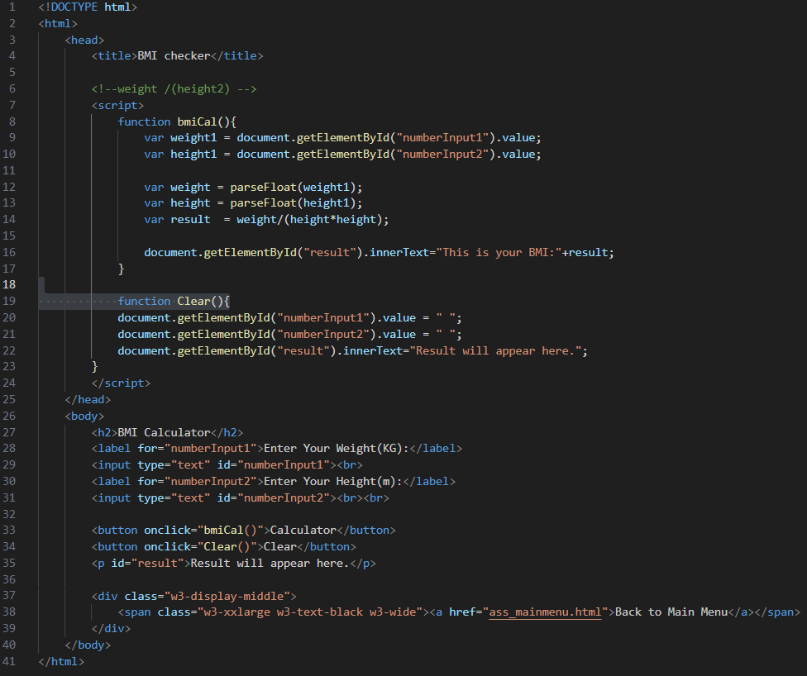

Output:

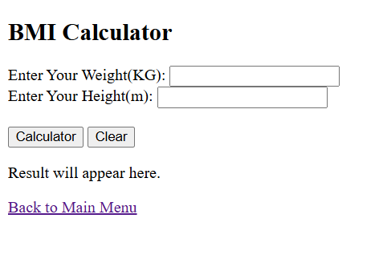

### 1.3.2 SimpleCalculator.html

Coding:

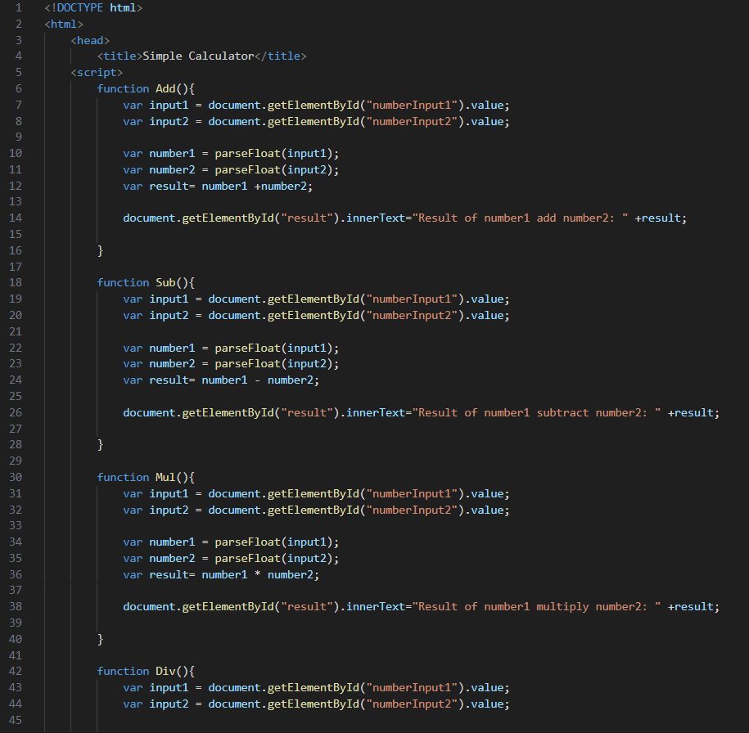

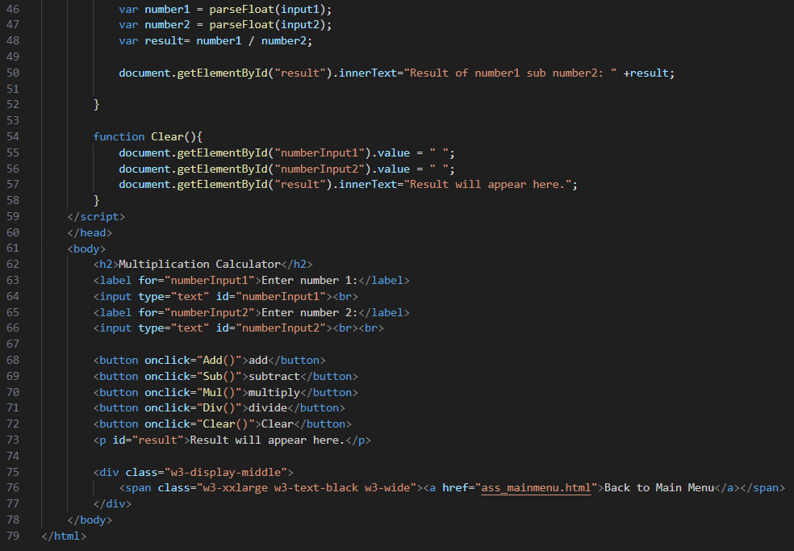

Output:

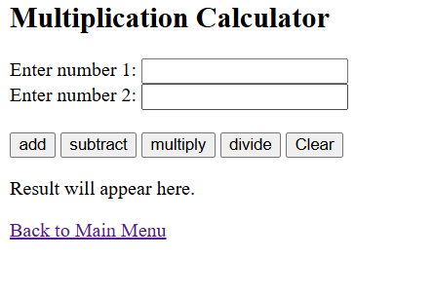

### 1.3.3 Unit Converter

Coding: 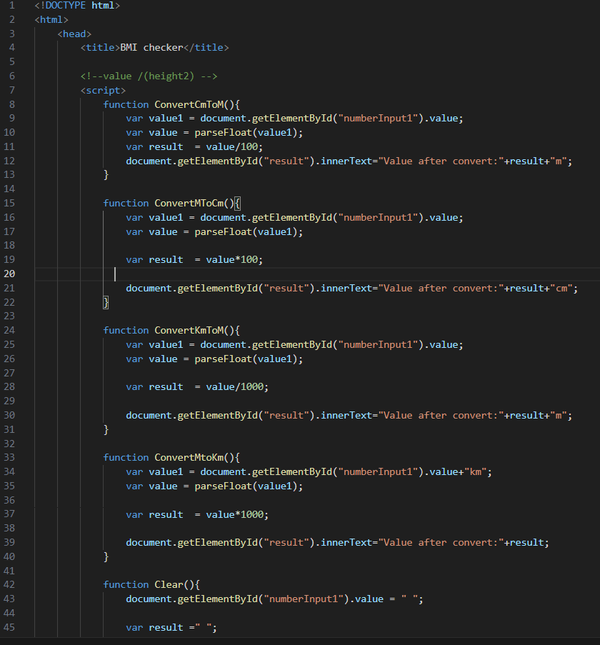

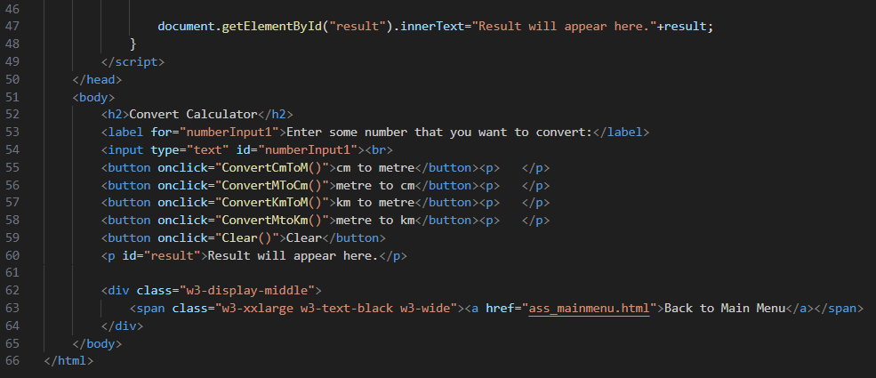

Output:

